A novel β-N-acetyl glucosaminidase from Chitinolyticbacter meiyuanensis possessing transglycosylation activity and its use in generating long-chain N-acetyl chitooligosaccharides
Alei Zhang, Xiaofang Mo, Ning Zhou, Yingying Wang, Guoguang Wei, Jie Chen, Kequan Chen*, Pingkai Ouyang
State Key Laboratory of Materials-Oriented Chemical Engineering, College of Biotechnology and Pharmaceutical Engineering, Nanjing Tech University, Nanjing, 211800, P.R. China
*Corresponding author: Tel.: +86-138-1418-0652
E-mail address: kqchen@njtech.edu.cn

Table S1 Strains, plasmids, and primers used in this study
Strain, plasmid,  or primer | Descriptionª | Source
Strains  E.coli DH5α  E.coli BL21(DE3)  Strain SYBC-H1 | ϕ80dlacZΔM15 Δ(lacZY-argF)U169 deoR recA1 endA1 hsdR17(r_{k}⁻ m_{k}⁺) supE44 thi-1 gyrA96 relA1  F⁻ ompT hsdS_{B}(r_{B}⁻m_{B}⁻) gal dcm (DE3)  Wild type, isolated from soil | Invitrogen  Novagen  This study
Plasmids  pMD19-T simple  pET28a(+)  pMD19-CmNAGase  pET28a(+)-CmNAGase | E.coli cloning vector; Amp^{r}  E.coli expression vector,T7 RNA polymerase gene promoter and terminator; Kan^{r}  pMD19-T simple derivate, containing the CmNAGase gene from SYBC-H1 strain  7.1-kb pET28a(+) derivate carrying the CmNAGase gene | TaKaRa  Novagen  This study  This study
Primers  F1  R1 | GAATTCCATATGATGAGCCGTCCCGCCGGATC  TCCGCTCGAGTCAGGCGCCCACCTGCACCG
ªUnderlined sequences within the primers are the NdeI and XhoI restriction sites. Amp^{r}, ampicillin resistance; Kan^{r}, kanamycin resistance.

Table S2 Purification of recombinant CmNAGase.
Purification method | Total activity  (U) | Total protein  (mg) | Specific activity (U/mg) | Purification (fold) | Recovery yield (%)
Crude enzyme | 60,604.2 | 19.2 | 3,156.5 | 0 | 100
Ni–NTA resin | 48,786.4 | 10.4 | 4,878.6 | 1.5 | 80.5

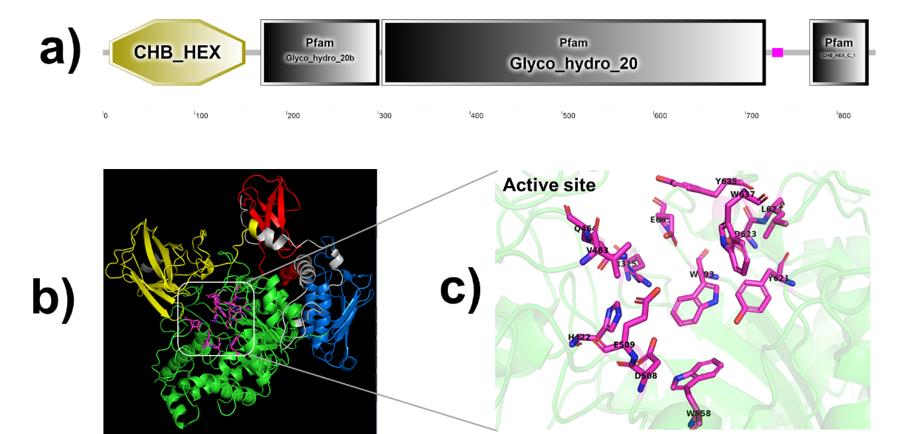

Fig. S1 The domain and structure prediction of CmNAGase. a) The conserved domain of CmNAGase. b) The prediction of the 3D structure of CmNAGase. Yellow color, CHB_HEX domain; Blue color, Glyco_hydro_20b domain; Green color, Glyco_hydro_20 domain; Red color, CHB_HEX C_1 domain; Gray color, unknow region. c) The active site of CmNAGase. D508 and E509 were the active residues.

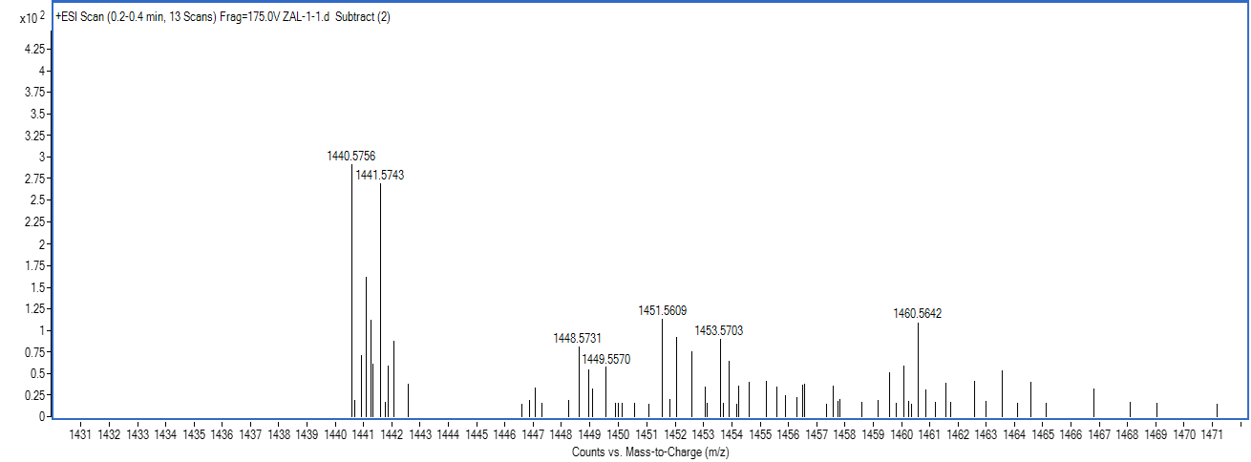
Fig. S2 Mass spectrum of new peak (~16.0 min) after (GlcNAc)₆ in HPLC spectra.

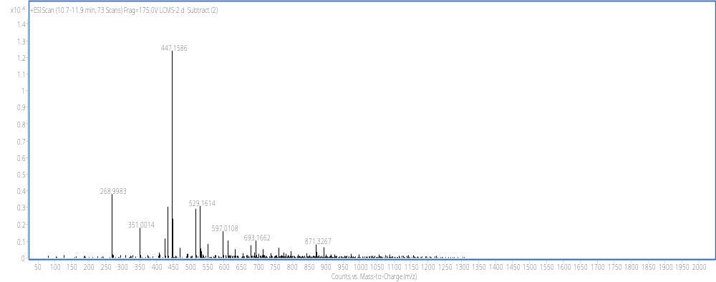
Fig. S3 Mass spectrum of peak 2 (~10.9 min) in HPLC spectra.

